PART-A

PRELAB:

2.

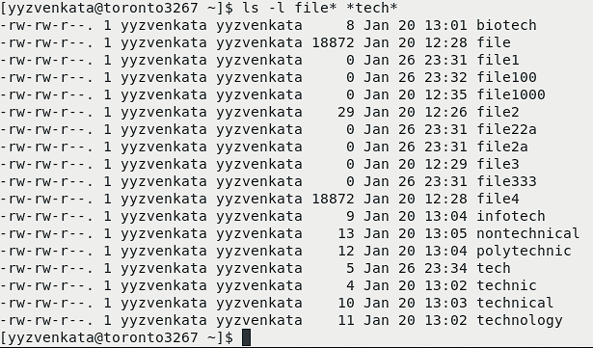

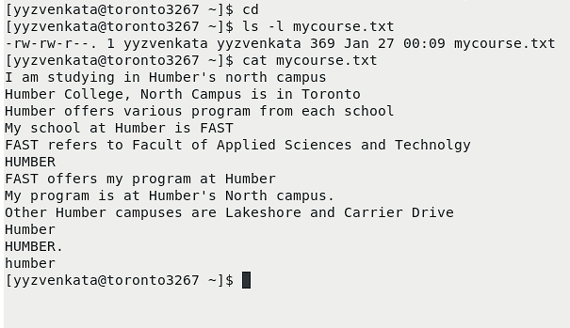

PART -B: 4,5,6,7 – LISTING FILES , WILD CARD

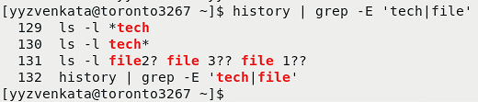

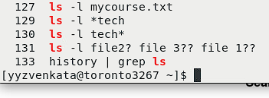

PART C: REG EX

8.

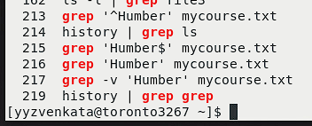

9.

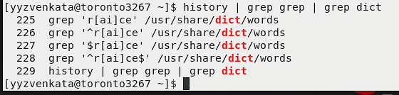

PART-D PRINTING:

10.

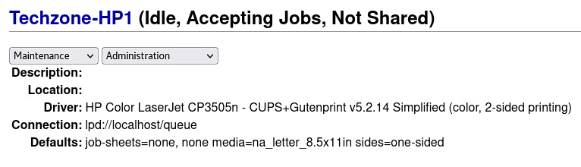

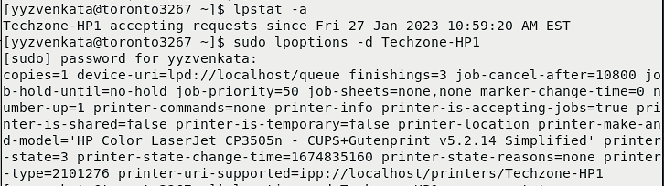

11.

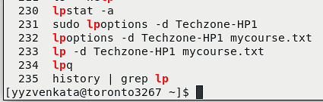

PART – E

USING ECHO COMMANDS AND VARIABLES

12,13,14,15,16:

